# Course Menu

This application implements an application that allows the user to enter a course number and receive the instructor, room and time of the course.

In the main section of the code, a function named print_menu is defined. This function accepts the following parameter:

* rooms: room
  + room is a list of rooms

The function print_menu outputs a list of course numbers to help the user make a valid entry.

Available courses:  
CSC101

CSC102

CSC103

NET110

COM241

q to quit

Input the course number:

When the user enters a valid course number, the application prints a message containing the course number, the room, time, and instructor. If the user enters an invalid course number, an error message is displayed stating the course is unknown.

Note that lists are used to populate the initial values of the course numbers, rooms, instructors, and times. This is done so the dictionaries can be created from these lists and the course numbers only occur in one place.

## Flowchart

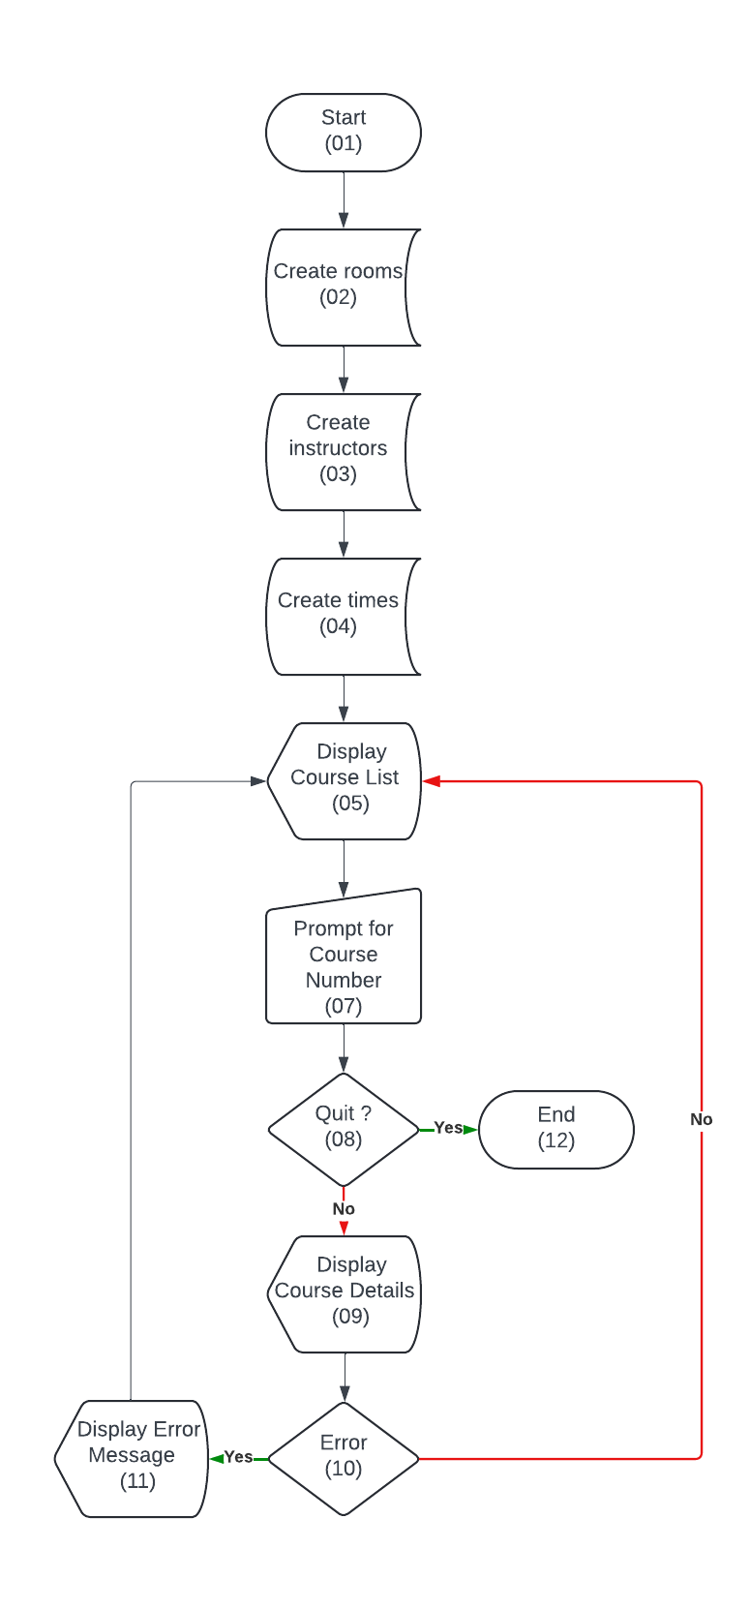

## Python Code

# Create list of courses, rooms, instructors, times so they only occur once in the program. Indexes line up.

course_numbers = ['CSC101','CSC102','CSC103','NET110','COM241']

course_rooms = ['3004','4501','6755','1244','1441']

instructor_names = ['Haynes','Alvarado','Rich','Burke','Lee']

course_times = ['8:00 a.m.','9:00 a.m.','10:00 a.m.','11:00 a.m.','1:00 p.m.']

# Create rooms dictionary

rooms = {}

index = 0

for course in course_numbers:

rooms[course] = course_rooms[index]

index += 1

# Create instructors dictionary

instructors = {}

index = 0

for course in course_numbers:

instructors[course] = instructor_names[index]

index += 1

# Create times dictionary

times = {}

index = 0

for course in course_numbers:

times[course] = course_times[index]

index += 1

def print_menu(course_numbers):

print('\nAvailable courses:\n')

for course in course_numbers:

print(course)

print('q to quit')

return input('\nInput the course number: ')

if __name__ == "__main__":

course_number = ''

while course_number != 'q':

course_number = print_menu(course_numbers)

if course_number != 'q':

try:

print('\nCourse {} meets in room {} at {} with Dr. {}.'.format(course_number,rooms[course_number],times[course_number],instructors[course_number]))

except:

print('\nUnknown course, try again.\n')

## Output

# Git-repo

<https://github.com/tlerunner/git-repo/tree/main/Module%206>